

Welcome to the Center for California Real Estate's (CCRE) monthly marketing toolkit of slides, social posts and additional resources exploring consumer issues in residential real estate. ​​​​Download ​​​​these tools to enhance your marketing plans and spark conversations in your spheres of influence.
This month, we’re taking a look at how to combat consumer uncertainty. This month’s toolkit addresses rising consumer anxiety about the economy and equips REALTORS® with strategies to respond. It highlights how homeownership can provide stability, long-term financial security, and even greater satisfaction — making it a powerful hedge against uncertainty.

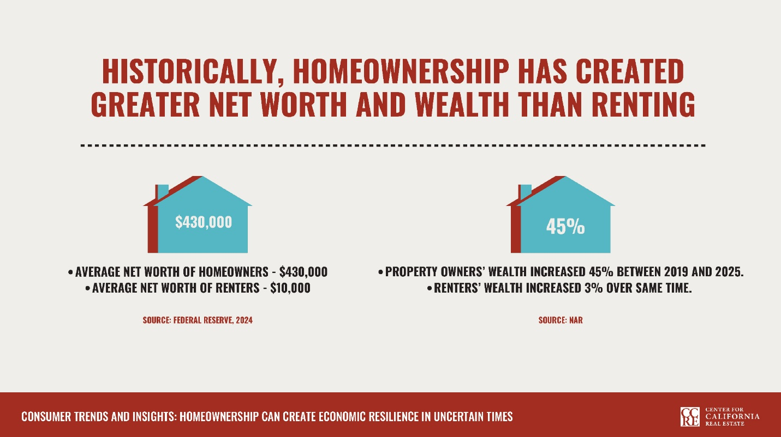

SLIDE DECK: Only 34% of Americans feel financially secure. The data in these slides show how homebuying can contribute to new worth and financial resilience.
Download and insert these slides into a listing presentation for clients concerned about the economic climate. View the deck as a slide show in your next office meeting to brainstorm marketing to clients worried about the economy.

 | 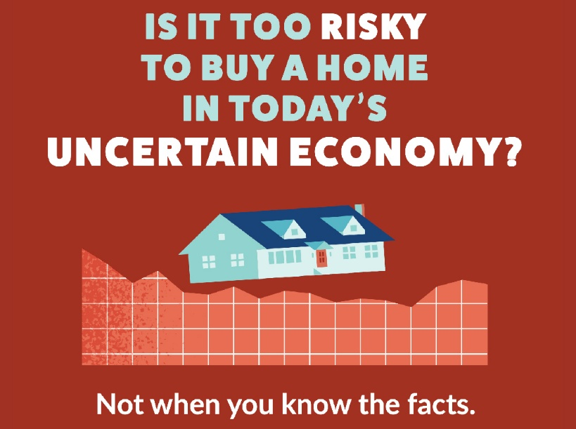 |  | SOCIAL MEDIA POSTS: Download and share these social posts to combat buyers' and sellers' economic anxiety.
 | INFOGRAPHIC:  Share 7 Benefits of Buying a Home in an Uncertain Economy, featuring space for your contact info. |  | 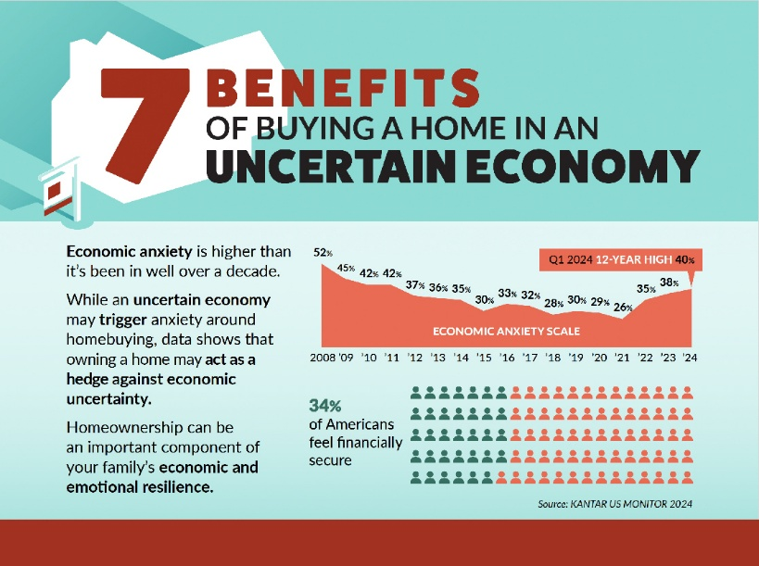

 | TOP 5 TAKEAWAYS: Consider these key points to help turn consumer anxiety into opportunity.
 |  |  | Clients are feeling unprecedented anxiety about the economy, and REALTORS® must be prepared to address that fear directly.
 |  |  | Homeownership can serve as a hedge against economic uncertainty by providing a means to grow net worth through appreciation, equity, and stable housing costs. The average net worth of homeowners is over 40 times the net worth of renters.
 |  |  | Homeownership can provide income and security through multigenerational living and income-producing rentals. An ADU can increase a property’s value upward of 25%.
 |  |  | In an uncertain economy, buyers may focus on the long-term cost savings a property will provide, and sellers may want to emphasize the practical benefits of their property.
 |  |  | Homeownership can provide benefits to both financial and emotional well-being. 90% of homeowners say they’re happier overall since they bought a home.

Missed an issue? Visit the Consumer Trends and Insights archive on the CCRE website.
Disclaimer: Use of the materials contained in CCRE Consumer Trends and Insights must include proper attribution to Kantar, LLC. Attribution is already built into the downloadable tools, and members are asked not to remove or alter these credits when sharing with clients or the public.

Advertising Inquiries: learn how you can advertise in this email newsletter.
CALIFORNIA ASSOCIATION OF REALTORS® • 915 L Street, #1460, Sacramento, CA 95814
Copyright © 2025, All rights reserved.

